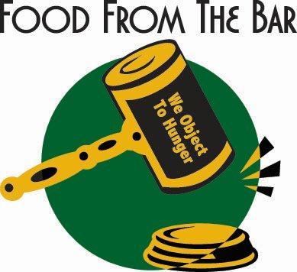
Food from the Bar
Inaugural Food and Funds Challenge

The Association for Women Attorneys, Louisiana Association of Black Women Attorneys, and International Women's Insolvency & Restructuring Confederation are hosting the second, annual New Orleans Food from the Bar Campaign. This campaign is part of a food drive by legal communities across the country, in which participants raise funds for and donate food to local food banks. Generally, the program runs in the spring to replenish food bank supplies in anticipation of higher demand during summer months when children are not in school and therefore not receiving subsidized meals.

How it works:
We challenge you to participate in a competitive food and fundraising drive intended to inspire a little healthy competition between our law firms and help raise critical support for the campaign. During the drive, your firm will be awarded points for financial donations and food donations to Second Harvest Food Bank. The Drive begins with our kickoff celebration on May 23rd and ends on June 7 and the firm with the highest score on that day will receive a Snowball Day in their office, compliments of Baker Donelson. Consider an intra-firm competition – law school groups versus each other, staff versus attorney, etc.
Scoring:
$1 donated = 1 point
5 pounds of food donated = 1 point

We encourage you to participate in this important program. Too many children in our area are missing critical nutrition during the summer and Food From the Bar can help fill that need.
Second Harvest will collect food and funds from each firm the week of June 10. Please make checks payable to Second Harvest Food Bank. Contact Kathryn Gsell at Second Harvest with any questions you may have: kgsell@secondharvest.org or 504-729-2820.
