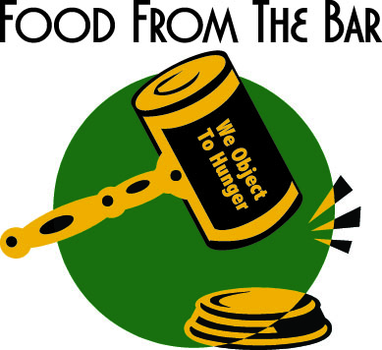

Corporate Sponsorship Information

The Association of Women Attorneys, Louisiana Association of Black Women Attorneys, and International Women’s Insolvency & Restructuring Confederation are pleased to offer your organization a great opportunity to become a valuable sponsor of the Second Annual New Orleans Food from the Bar Campaign.
Food from the Bar is the legal community’s response to child hunger across the country, in which participants raise funds, donate food, and volunteer at local food banks. Last spring, we hosted the first Food from the Bar campaign in New Orleans to benefit Second Harvest Food Bank of Greater New Orleans & Acadiana.
This year, we will host a kick-off event at Alexis Walter Art on Julia Street
Hunger doesn’t take a summer vacation when school food programs do. During summer months, thousands of children lose access to breakfast and lunch programs, a critical source of nutrition. Food from the Bar provides support for summer food programs so that kids get the nutrition they need to live healthy and productive lives.
Please join your colleagues for a kick-off reception to learn more about childhood hunger in our community and what you can do to help.

The Campaign Kick-Off Event

When: Thursday, May 23, 2013 – 5:30 p.m.

Where: Alexis Walter Art, 835 Julia Street

Why: Raise awareness while networking and fundraising!

How: Become a corporate sponsor.

For more information please contact April Watson, Community Outreach Chair, Association of Women Attorneys, awatson@sessions-law.com or at 504-582-1506.

Corporate Sponsorship Form

$2,500 “Head Chef”
• Title Sponsorship for Food from the Bar Campaign
• Name included on website and email advertising for the kick-off and awards event
• Name and/or logo featured on donor sponsor board at kick-off and awards event
• Special Recognition at the kick-off and awards event
• 20 tickets to kick-off event ($500 value)

$1,000 “Sous Chef”
• Name included on website and email advertising for the kick-off and awards event
• Name and/or logo on donor sponsor board at kick-off and awards event
- 12 tickets to kick-off event ($300 value)

$500 “Gourmet”
• Name included on website and email advertising for the kick-off and awards event
• Name and/or logo on donor sponsor board at kick-off and awards event
• 8 tickets to kick-off event ($200 value)

$250 “Foodie”
• Name and/or logo on donor sponsor board at kick-off and awards event
• 4 tickets to kick-off event ($100 value)

Sponsoring Organization:

_______________________________________________________
Sponsorship Level:

_______________________________________________________
Contact Person: Email address:

_______________________________________________________
Mailing Address: Telephone Number:

_______________________________________________________
Please forward the completed form along with your sponsorship check payable to “Second Harvest Food Bank” to the attention of Kathryn Gsell, Second Harvest Food Bank, 700 Edwards Avenue, New Orleans, LA 70123.

